Network operating system

Network Operating System is an operating system that includes special functions for connecting computers and devices into a local-area network (LAN) or Inter-network. Short form of Network Operating system is NOS. Some popular network operating systems are Novell Netware, Windows *NT/2000,*Linux, Sun Solaris, UNIX, and IBM *OS/2.*The network operating system which was first developed is Novell Netware. It was developed in 1983.

An operating system that provides the connectivity among a number of autonomous computers is called a network operating system. A typical configuration for a network operating system is a collection of personal computers along with a common printer, server and file server for archival storage, all tied together by a local network.

Some of the features of Network Operating System are to:

• It allows multiple computers to connect so that they can share data, files and hardware devices.

• Provide basic operating system features such as support for processors, protocols, automatic hardware detection and support multi-processing of applications.

• Provide security features such as authentication, logon restrictions and access control.

• Provide name and directory services.

• Provide file, print, web services and back-up services.

• Support Internetworking such as routing and WAN ports.

• User management and support for logon and logoff, remote access; system management, administration and auditing tools with graphical interfaces.

•It has clustering capabilities.  
• It has internetworking features. Example: Routing.

•In this, the users can remotely access each other.  
•It also includes security features.  
Example: authentication of data, restrictions on required data, authorizations of users etc.  
•It can also manage directory and name services.  
• It also provides basic network administration utilities like access to the user.  
• It also provides priority to the printing jobs which are in the queue in the network.  
• It detects the new hardware whenever it is added to the system.

**Types of Network Operating Systems**

Peer-to-peer network operating systems allow users to share resources and files located on their computers and to access shared resources found on other computers. In a peer-to-peer network, all computers are considered equal; they all have the same privileges to use the resources available on the network. Peer-to-peer networks are designed primarily for small to medium local area networks. Windows for Workgroups is an example of the program that can function as peer-to-peer network operating systems.

Advantages of Peer-to-Peer(P2P)  Operating System are as follows:

• Less requirement of hardware is there.  
• No server needs to be established.  
• Its setup process is natural.

Disadvantages of Peer-to-Peer(P2P)  Operating System are as follows:

• It has no central location for storage, i.e. different systems have different storage capacity.  
• It has less security as compared to the client-server model.

Client/server network operating systems allow the network to centralise functions and applications in one or more dedicated file servers. The file servers become the heart of the system, providing access to resources and providing security. The workstations (clients) have access to the resources available on the file servers. The network operating system allows multiple users to share the same resources irrespective of physical location simultaneously. Novell Netware and Windows 2000 Server are examples of client/ server network operating systems.

Each computer in the workgroup run an autonomous operating system; yet cooperate to allow a variety of facilities including sharing of files, sharing of hardware resources and execution of remote machines etc.

Network operating systems are implementations of loosely coupled operating systems on top of loosely coupled hardware. Network operating\systems is the software that supports the use of a network of machines and provides users that are aware of using a set of computers, with facilities designed to ease the use of remote resources located over the network. These resources are made available as services and might be printers, processors, file systems or other devices. Some resources, of which dedicated hardware devices such as printers, tape drives are connected to and managed by a particular machine and are made available to other machines in the network via a service. A typical example of such a system is a set of workstations connected through a local area network (LAN). Every workstation has its operating system every user has its workstation in exclusive use and cooperates to allow a variety of facilities including sharing of files, sharing of hardware resources and execution of remote machines etc. A user can execute a login command to connect to another station and also can access a set of shared files maintained by a workstation named/file server.

Advantages of Client Server Operating System are as follows:

•  In this, security to the machines is provided through the server.  
•  Here, hardware can be easily connected to the system.  
•  Also, new technology is easily integrated into the system.  
•  The central server is more stable in a client-server model.  
•  Hardware and the operating system can be specialised.  
•  In this model, different machines can remotely access the server from different locations.

Disadvantages Client Server Operating System are as follows:

• It seems to be costly as buying and running a server is cost effective.  
• Also, here we always have to depend on the central location for any type of operation like for storage, for accessing of data etc..  
• It requires regular maintenance.  
• Daily updation is required as per requirement.

CLIENT SERVER NETWORK

A Computer networking model where one or more powerful computers (servers) provide the different [computer](http://ecomputernotes.com/fundamental/introduction-to-computer/what-is-computer) network services and all other user'of computer  network (clients) access those services to perform user's tasks is known as client/server computer networking model.  
• In such networks, there exists a central controller called server. A server is a specialized computer that controls the network resources and provides services to other computers in the network.

• All other computers in the network are called clients. A client computer receives the requested services from a server.  
• A server performs all the major operations like security and network management.  
• All the clients communicate with each other via centralized server  
• If client 1 wants to send data to client 2, it first sends request to server to seek permission for it. The server then sends a signal to client 1 allowing it to initiate the communication.  
• A server is also responsible for managing all the network resources such as files, directories, applications & shared devices like [printer](http://ecomputernotes.com/fundamental/input-output-and-memory/what-is-a-printer-and-what-are-the-different-types-of-printers) etc.  
• If any of the clients wants to access these services, it first seeks permission from the server by sending a request.  
• Most Local Area Networks are based on client server relationship.

Client-server networking became popular in the late 1980s and early 1990s as many applications were migrated from centralized minicomputers and mainframes to computer networks of persona computers.

[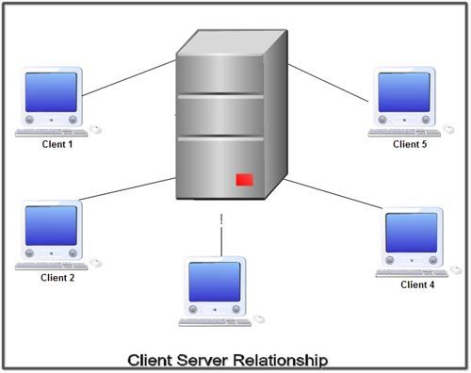](http://ecomputernotes.com/images/Client-Server-Relationship.jpg)

The design of applications for a distributed computing environment required that they effetely be divided into two parts: client (front end) and server (back end). The network model on which they were implemented mirrored this client-server model with a user's PC (the client) typically acting as the requesting machine and a more powerful server machine to which it was connected via either a LAN or a WAN acting as the supplying machine. It requires special networking [operating system](http://ecomputernotes.com/fundamental/disk-operating-system/what-is-operating-system). It provides user level security and it is more expensive.

Advantages of Client Server Networks

1. Centralized back up is possible.

2. Use of dedicated server improves the performance of whole system.

3. Security is better in these networks as all the shared resources are centrally administered.

4. Use of dedicated servers also increases the speed of sharing resources.

Disadvantages of Client Server Networks

1. It requires specialized servers with large memory and secondary storage. This leads to increase in the cost.

2. The cost of network operating system that manages the various clients is also high.

3. It requires dedicated network administrator.

Difference between client server and peer to peer

| BASIS FOR COMAPAISON | CLIENT-SERVER | PEER-TO-PEER |
| --- | --- | --- |
| Basic | There is a specific server and specific clients connected to the server. | Clients and server are not distinguished; each node act as client and server. |
| Service | The client request for service and server respond with the service. | Each node can request for services and can also provide the services. |
| Focus | Sharing the information. | Connectivity. |
| Data | The data is stored in a centralized server. | Each peer has its own data. |
| Server | When several clients request for the services simultaneously, a server can get bottlenecked. | As the services are provided by several servers distributed in the peer-to-peer system, a server in not bottlenecked. |
| Expense | The client-server are expensive to implement. | Peer-to-peer are less expensive to implement. |
| Stability | Client-Server is more stable and scalable. | Peer-toPeer suffers if the number of peers increases in the system. |

Definition of Client-Server

The Client-Server network model is widely used network model. Here, **Server** is a powerful system that stores the data or information in it. On the other hands, the **Client** is the machine which let the users access the data on the remote server.

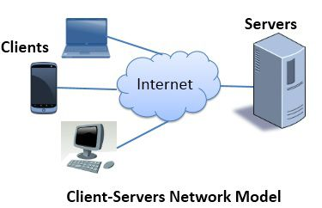The **system administrator** manages the data on the server. The client machines and the server are connected through a **network**. It allows the clients to access data even if the client machine and server are far apart from each other.

In Client-Server model, the client process on the client machine sends the **request** to the server process on the server machine. When the server receives the client request, it lookouts for the requested data and **send** it back with the reply.

Definition of Peer-to-Peer

Unlike Client-Server, the Peer-to-Peer model does not distinguish between client and server instead each **node** can either be a client or a server depending on the whether the node is **requesting** or **providing** the services. Each node is considered as a **peer**.

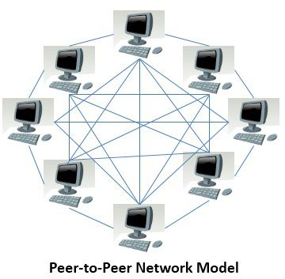To become a part of peer-to-peer, a node must initially **join** the network. After joining it must start to provide services to and must request the services from other nodes in the peer-to-peer system. There are **two ways** to know which node provides which services; they are as follow:

When a node enters the peer-to-peer system, it must **register** the services it will be providing, into a **centralized lookup service** on the network. When a node desires for any specific service it must contact centralized lookup services to check out which node will provide the desired services. Rest of the communication is done by the desiring node and the service providing node.

A node desiring for the specific services must **broadcast** the request for services to all other nodes in the peer-to-peer system. The node providing the requested service will **respond** to the node making the request.

Peer-to-Peer network has the advantage over client-server that the server is **not bottlenecked** as the services are provided by the several nodes distributed in a peer-to-peer system.

Key Differences Between Client-Server and Peer-to-Peer network

The key difference between Client-Server and Peer-to-Peer network is that there is a **dedicated server** and **specific clients** in the client-server network model whereas, in peer-to-peer each **node** can act as **both** server and client.

In the client-server model, the **server** provides **services** to the client. However, in peer-to-peer, each **peer** can provide **services** and can also **request** for the services.

In the client-server model, **sharing information** is more important whereas, in peer-to-peer model **connectivity** between peers is more important.

In the client-server model, data is stored on a **centralized** server whereas, in peer-to-peer **each peer has its own data**.

In peer-to-peer model, the **servers are distributed** in a system, so there are fewer chances of server getting bottlenecked, but in the client-server model, there is a **single server serving the clients**, so there are more chances of server getting bottlenecked.

The client-server model is more **expensive** to implement than peer-to-peer.

The client-server model is more **scalable**and **stable** than peer-to-peer.